MDC-64 Blade Replacement Instructions
- Remove the hook on the lower part of the handle
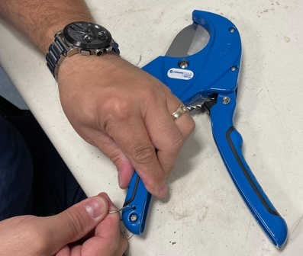
- Unscrew the 2 screws of the rigid handle and remove the grip
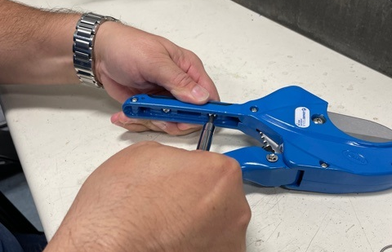

- Remove the 5 screws holding the housing together, and remove the faceplate
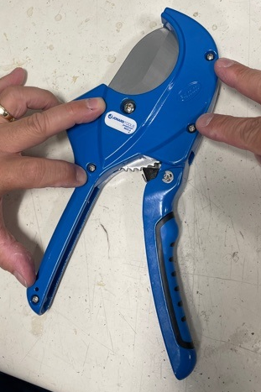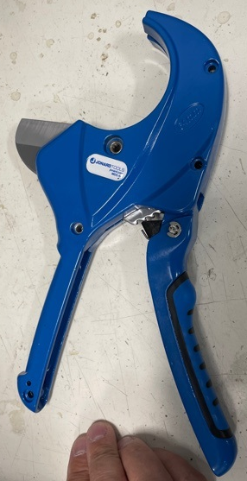
- While the faceplate is open, remove the dull blade
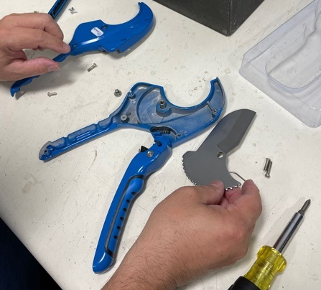
- Position the moveable handle so that the pin is situated, and the lever is contacting the spring
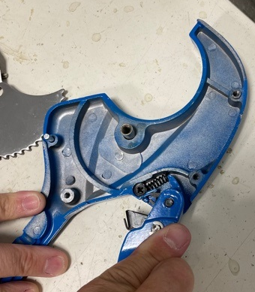
- While holding the moveable handle in place, put the new blade into the housing
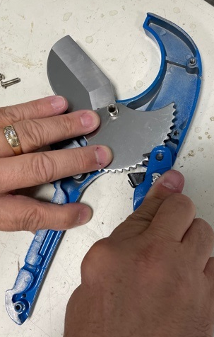

- Position the torsion spring so that it is contacting the flat part of the back of the blade
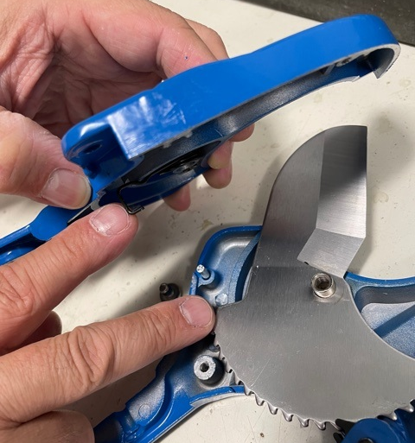
- Fit the faceplate back onto the unit it snaps into place and replace the assembly.


